In-class Exercise

1. Write a procedure “PrintVendorName” that has one input parameter. The parameter is vendor ID. Print out the vendor’s name and city. (20 points)

Execute the procedure with input 83

Write your procedure PrintVendorName here:

“set serveroutput on;

create or replace procedure PrintVendorName(v_id in number) is

cursor vendor_cursor is

select vendor_name, vendor_city

from vendors

where vendor_id = v_id;

vendor_row vendor_cursor%rowtype;

begin

for vendor_row in vendor_cursor loop

dbms_output.put_line('Name is' || vendor_row.vendor_name || 'Vendor City is '||vendor_row.vendor_city);

end loop;

end;”

“execute PrintVendorName(83);”

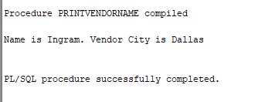

1. Implement a function **invoiceCheck** with one input parameter (invoice number) to check if the invoice exists in your database. Write a procedure **InvoiceDetail** with one input parameter (invoice number). In the procedure, call the function invoiceCheck to check if the invoice exists, if yes, display the invoice_id, invoice_total and invoice_due_date for that invoice. If not, print out a message “invoice not in the database” from your procedure. (80 points)

Execute the procedure with inputs “QP58872” and “ILO230” .

Write your function invoiceCheck here:

“create or replace function invoiceCheck(invoice in varchar2)

return char is

exist char;

try invoices.invoice_number%type;

begin

select invoice_number into try

from invoices

where invoice = invoice_number;

if invoice = try

then exist := 'y';

else exist := 'n';

end if;

return exist;

end;”

Write your Procedure invoiceDetails here:

“set serveroutput on;

create or replace procedure InvoiceDetail(invoice in varchar2) is

i_id number;

i_total number;

i_due_date date;

begin

if invoiceCheck(invoice) = 'y'

then

select invoice_id, invoice_total, invoice_due_date

into i_id, i_total, i_due_date

from invoices

where invoice = invoice_number;

dbms_output.put_line('Invoice ID: '|| i_id ||' Invoice Total: '|| i_total ||' Invoice Due Date: '|| i_due_date);

else

raise no_data_found;

end if;

exception when no_data_found then

dbms_output.put_line('Invoice not in the database');

end;”

“execute invoiceDetail(' QP58872');”

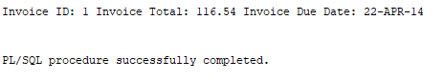

“execute invoiceDetail('ILO230');”

